# TryHackMe Room: [Hello World](https://tryhackme.com/room/hello)

**Learning Objective**

The primary goal of the "Hello World" room on TryHackMe is to introduce users to the platform and familiarize them with its structure, navigation, and basic of cyber security.

**Key Tools/Commands Used**

* **Web Browser:** Used to access the TryHackMe platform.
* **TryHackMe Dashboard:** Explored the interface and features.
* **Basic Navigation Commands:** Learned how to move through rooms and access content.

**Concepts Learned** :- **Platform Overview:**

* + Understanding the purpose of TryHackMe.
  + Introduction to its features such as learning paths, hands-on , etc

1. **Room Navigation:**
   * How to join rooms, complete tasks, and track progress.
2. **Cybersecurity Basics:**
   * Introduction to ethical hacking concepts and system security principles.

**Walkthrough / How You Solved It**

1. **Accessing the Room:**
   * Logged into TryHackMe using credentials.
   * Navigated to the "Hello World" room via the provided link ([TryHackMe Hello World)](https://tryhackme.com/room/hello).
2. **Exploring Content:**
   * Followed the guided instructions within the room.
   * Completed introductory tasks designed to familiarize users with TryHackMe's interface.
3. **Hands-On Practice:**
   * Engaged in simple exercises demonstrating basic cybersecurity principles.
4. **Completion:**
   * Marked tasks as complete after successfully understanding the content.

**Reflections or Notes**

* The "Hello World" room is an excellent starting point for beginners in cybersecurity.
* It highlights the importance of hands-on practice in building foundational skills.
* The interactive environment fosters curiosity and encourages further exploration of cybersecurity topics.

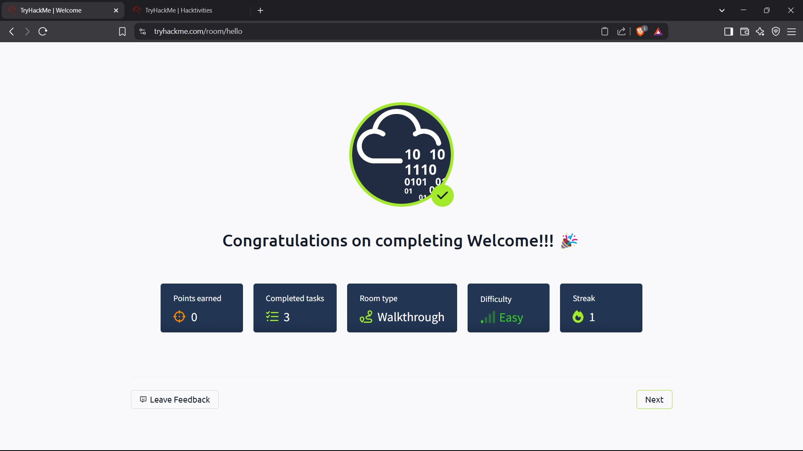

## TryHackMe Room: [How to Use TryHackMe](https://tryhackme.com/room/howtousetryhackme)

**Learning Objective**

The "How to Use TryHackMe" room is designed to help users understand the platform's structure, features, and navigation.

**Key Tools/Commands Used**

* **TryHackMe Dashboard**
* **Interactive Labs**
* **VPN Configuration**

**Concepts Learned**

1. **Platform Features:**
   * Overview of TryHackMe’s core functionalities, including learning paths, challenges, etc.
2. **Room Navigation:**
   * How to join rooms, complete tasks, and getting answer.
   * Room types such as walkthroughs and tutorials.
3. **Hands-On Practice:**
   * Accessing and using virtual environments for practical exercises.
4. **Security Basics:**
   * Setting up a secure connection using OpenVPN for accessing remote labs.

**Walkthrough / How You Solved It**

1. **Accessing the Room:**
   * Logged into TryHackMe and navigated to the "How to Use TryHackMe" room via the provided link [(TryHackMe How to Use TryHackMe)](https://tryhackme.com/room/howtousetryhackme).
2. **Exploring the Dashboard:**
   * Familiarized with key sections like "Learn," "Practice," "Compete," and "Networks."

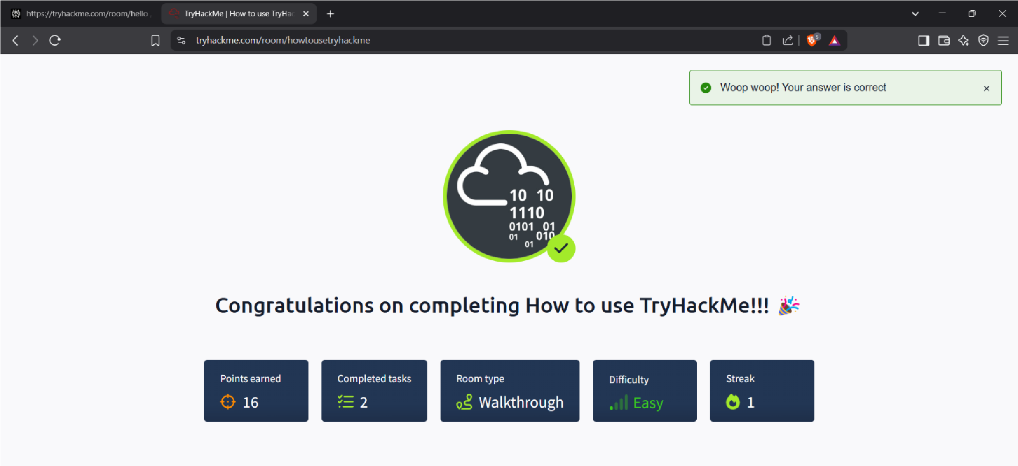

* + Reviewed available learning paths and room categories.

1. **Completing Tasks:**
   * Practiced deploying VMs and connecting via VPN for hands-on activities.
2. **Submission Process:**

o Answered questions based on the tasks completed .

**Reflections or Notes** :

* The gamified approach makes learning engaging, while hands-on labs provide practical experience.
* The structured guidance ensures users can confidently explore more advanced rooms after completing this one.

# TryHackMe Room: [Getting Started](https://tryhackme.com/room/gettingstarted)

**Learning Objective**

The "Getting Started" room on TryHackMe aims to introduce users to the platform's functionality and guide them through the initial steps required to begin their cybersecurity learning journey.

**Key Tools/Commands Used**

* **TryHackMe Dashboard**
* **Virtual Machines (VMs)**
* **VPN Configuration**

**Concepts Learned**  **Platform Navigation:**

* + How to find and join rooms, complete tasks, and track progress.

1. **Hands-On Labs:**
   * Deploying virtual machines for practical hacking exercises.
   * Understanding the importance of secure connections via VPN.
2. **Cybersecurity Basics:**
   * Introduction to ethical hacking principles and system security fundamentals.
3. **Gamification Features:**
   * Earning points, maintaining streaks, and competing in leaderboards.

**Walkthrough / How You Solved It**

1. **Accessing the Room:**
   * Logged into TryHackMe and navigated to the "Getting Started" room via the provided link [(TryHackMe Getting Started)](https://tryhackme.com/room/gettingstarted).
2. **Exploring Content:**
   * Followed step-by-step instructions to understand the platform’s features.
   * Deployed virtual machines for exercises.
   * Configured VPN for secure access to remote labs.
3. **Task Completion:**
   * Answered questions based on room content and marked tasks as complete.

**Reflections or Notes**

* The "Getting Started" room is a valuable resource for beginners.
* It emphasizes hands-on practice, which is crucial for building foundational cybersecurity skills.

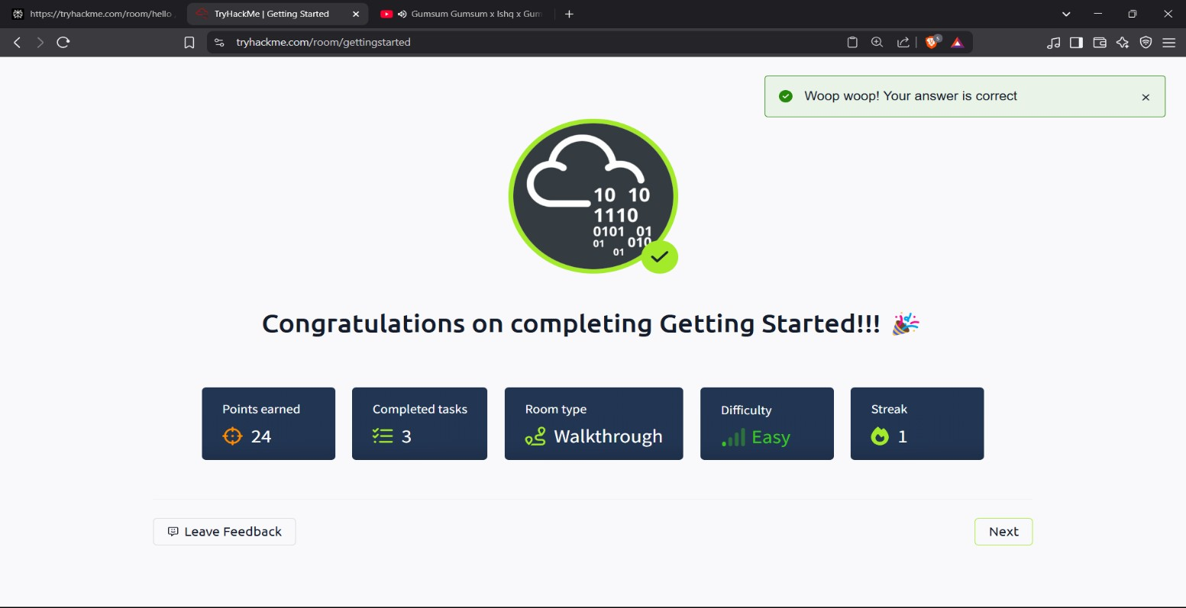

TryHackMe Room: [Welcome](https://tryhackme.com/room/welcome)

**Learning Objective**

The "Welcome" room on TryHackMe is designed as an introductory space for new users to familiarize themselves with the platform's goals and mission.

## TryHackMe Room: [TryHackMe Tutorial](https://tryhackme.com/room/tutorial)

**Learning Objective**

The "TryHackMe Tutorial" room aims to guide users through the fundamental features of the TryHackMe platform.

**Key Tools/Commands Used**

* **TryHackMe Interface**
* **Task Completion Interface**
* **Interactive Elements**.

**Concepts Learned**

1. **Room Structure:**
   * Identifying different types of tasks, such as multiple-choice, answer-based, and hands-on challenges.
2. **Task Interaction:**
   * Utilizing available resources like hints and explanations to solve tasks.

**Hands-On Practice:**

* + Using attack boxes to engage in practical cybersecurity exercises.

1. **Navigation Techniques:**
   * Efficiently navigating through rooms, tasks, and learning paths.

**Walkthrough / How You Solved It**

1. **Accessing the Room:**
   * Logged into TryHackMe and navigated to the "TryHackMe Tutorial" room via the provided link [(TryHackMe Tutorial)](https://tryhackme.com/room/tutorial).
2. **Exploring Content:**
   * Followed the tutorial's instructions to understand the room’s structure and available features.
   * Completed tasks step-by-step, using hints when needed to clarify concepts.
3. **Hands-On Practice:**
   * Deployed provided machines and utilized attack boxes to solve practical challenges.
   * Submitted answers for each task and tracked progress.
4. **Review and Completion:**
   * Reviewed completed tasks and ensured all concepts were understood.
   * Marked the room as complete after successfully finishing all tasks.

**Reflections or Notes**

* The "TryHackMe Tutorial" room is essential for new users.
* It emphasizes hands-on learning through interactive tasks and virtual machines, enhancing the learning experience.
* Understanding the tutorial’s content is crucial for effectively utilizing TryHackMe's resources and progressing through more advanced cybersecurity topics.

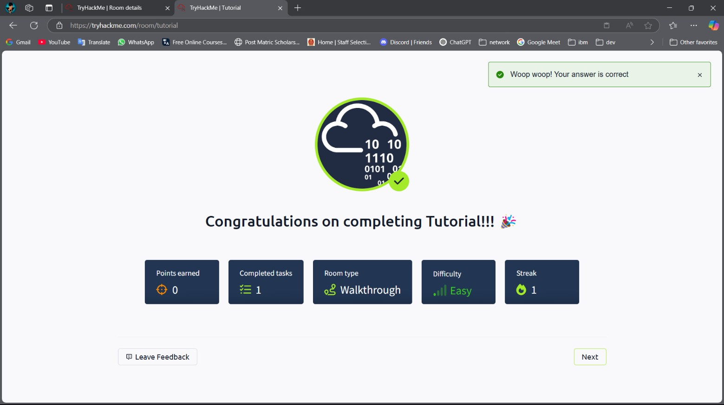

# TryHackMe Room: [OpenVPN](https://tryhackme.com/room/openvpn)

**Learning Objective**

The "OpenVPN" room on TryHackMe aims to guide users through the process of setting up and configuring an OpenVPN connection.

**Key Tools/Commands Used**

* **OpenVPN Client**
* **Terminal/Command Line**
* **ifconfig or ip addr**

**Concepts Learned**

1. **VPN Basics:**
   * Understanding what a VPN is and its purpose in cybersecurity.
   * Learning how VPNs provide secure and encrypted connections.
2. **OpenVPN Configuration:**
   * Downloading and using OpenVPN configuration files.
3. **Troubleshooting:**
   * Identifying and resolving common trouble shooting issues.

**Walkthrough / How You Solved It**

1. **Accessing the Room:**
   * Logged into TryHackMe and navigated to the "OpenVPN" room via the provided link ([TryHackMe OpenVPN)](https://tryhackme.com/room/openvpn).
2. **Downloading Configuration File:**
   * Followed instructions to download the appropriate OpenVPN configuration file.
3. **Installing OpenVPN Client:**
   * Installed the OpenVPN client on the local machine (e.g., using apt-get install openvpn on Linux).
4. **Connecting to VPN:**
   * Used the command line to connect to TryHackMe's network using the downloaded configuration file (sudo openvpn <your_username>.ovpn).
5. **Verifying Connection:**
   * Used ifconfig or ip addr to confirm the VPN interface (usually tun0) and assigned IP address.
   * Verified the connection was successful by accessing TryHackMe resources.
6. **Task Completion:**
   * Answered questions related to VPN setup and configuration.

**Reflections or Notes**

* It provides hands-on experience in configuring and verifying VPN connections, which is an essential skill in cybersecurity.
* Understanding how to troubleshoot VPN issues is valuable for maintaining a stable and secure connection.

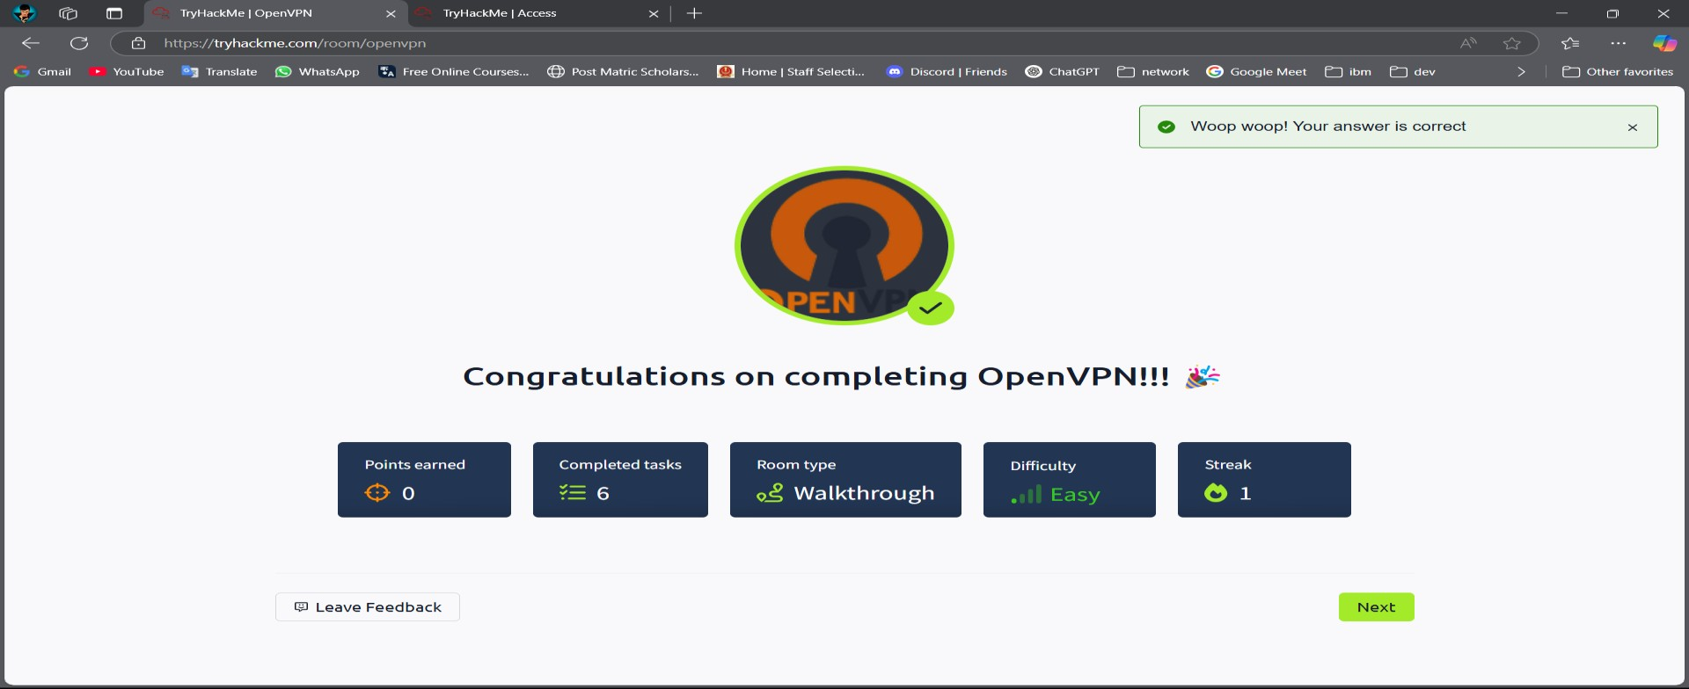

## TryHackMe Room: [Beginner Path Introduction](https://tryhackme.com/room/beginnerpathintro)

**Learning Objective**

The "Beginner Path Introduction" room on TryHackMe is designed to provide a comprehensive overview of the beginner learning path offered on the platform.

**Key Tools/Commands Used**

* **TryHackMe Learning Paths**
* **Module Overviews**
* **Room Previews**

**Concepts Learned**

1. **Learning Path Structure:**
   * Understanding how TryHackMe organizes content into structured learning paths.
   * Identifying the different modules and topics covered in the beginner path.
2. **Module Content:**
   * Reviewing the objectives and skills taught in each module, such as Linux fundamentals, web exploitation, and network security.
3. **Resource Utilization:**
   * Identifying key resources within the learning path, such as tutorials, walkthroughs, and supplementary materials.

**Walkthrough / How You Solved It**

1. **Accessing the Room:**
   * Logged into TryHackMe and navigated to the "Beginner Path Introduction" room via the provided link [(TryHackMe Beginner Path Introduction)](https://tryhackme.com/room/beginnerpathintro).
2. **Exploring the Path Overview:**
   * Reviewed the introduction to the beginner path and its overall objectives.
   * Navigated through the different modules to understand the content covered in each.
3. **Reviewing Module Content:**

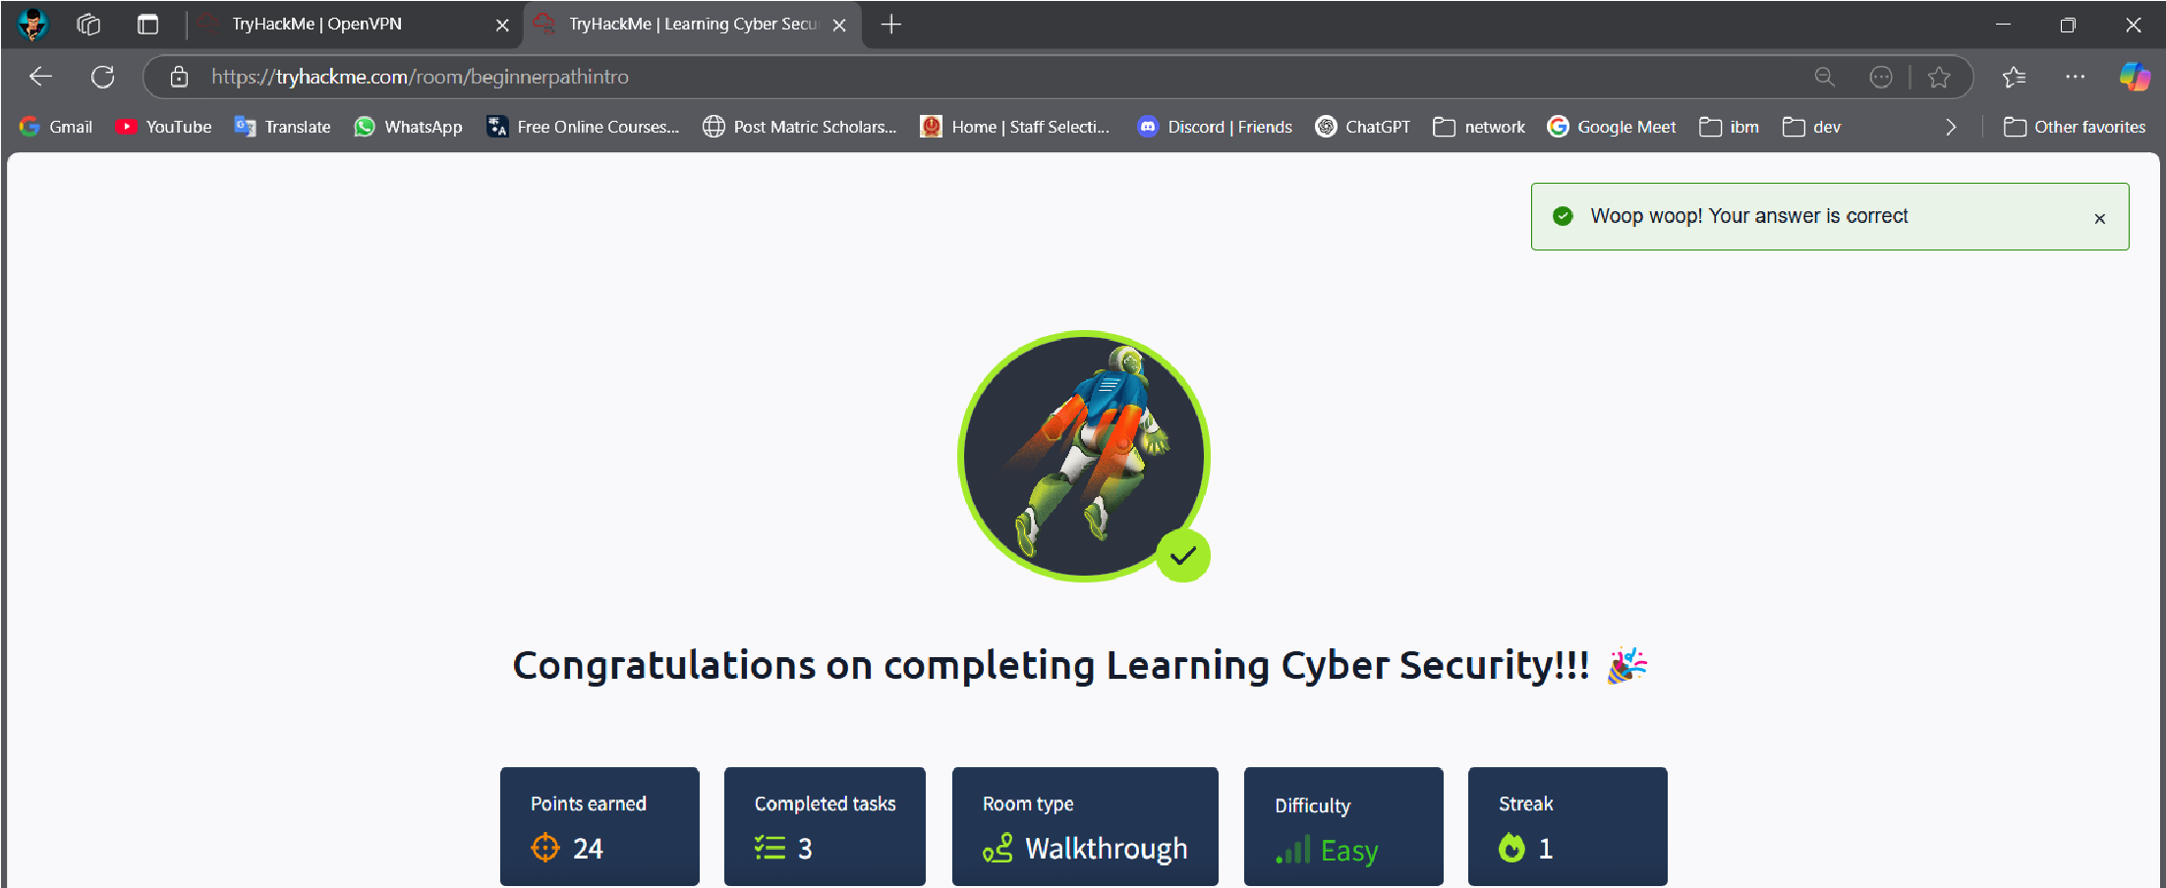

1. **Identifying Key Resources:**
   * Identified available resources, including tutorials, walkthroughs, and supplementary materials.
2. **Task Completion:**
   * Answered questions related to the beginner path and its modules.

**Reflections or Notes**

* Understanding the path's content and objectives is crucial for effectively progressing through the modules and developing key skills.

## TryHackMe Room: [Starting Out in Cyber Security](https://tryhackme.com/room/startingoutincybersec)

**Learning Objective**

The "Starting Out in Cyber Security" room on TryHackMe is designed to introduce users to the cybersecurity field.

**Key Tools/Commands Used**

* **TryHackMe Learning Paths**
* **Cybersecurity Role Descriptions**

**Concepts Learned**

1. **Cybersecurity Roles**
2. **Essential Skills**
3. **Career Planning**

**Walkthrough / How You Solved It**

1. **Accessing the Room:**
   * Logged into TryHackMe and navigated to the "Starting Out in Cyber Security" room via the provided link ([TryHackMe Starting Out in Cyber Security)](https://tryhackme.com/room/startingoutincybersec).
2. **Exploring Roles:**
   * Reviewed the descriptions of different cybersecurity roles and their responsibilities.
   * Identified roles that align with interests and skills.
3. **Exploring Learning Paths:**
   * Explored the recommended learning paths for different cybersecurity careers.
   * Understood how to structure learning to acquire the necessary skills.
4. **Task Completion:**
   * Answered questions related to cybersecurity roles, skills, and learning paths.

**Reflections or Notes**

* This room is invaluable for individuals starting their journey in cybersecurity, offering a clear overview of the field.

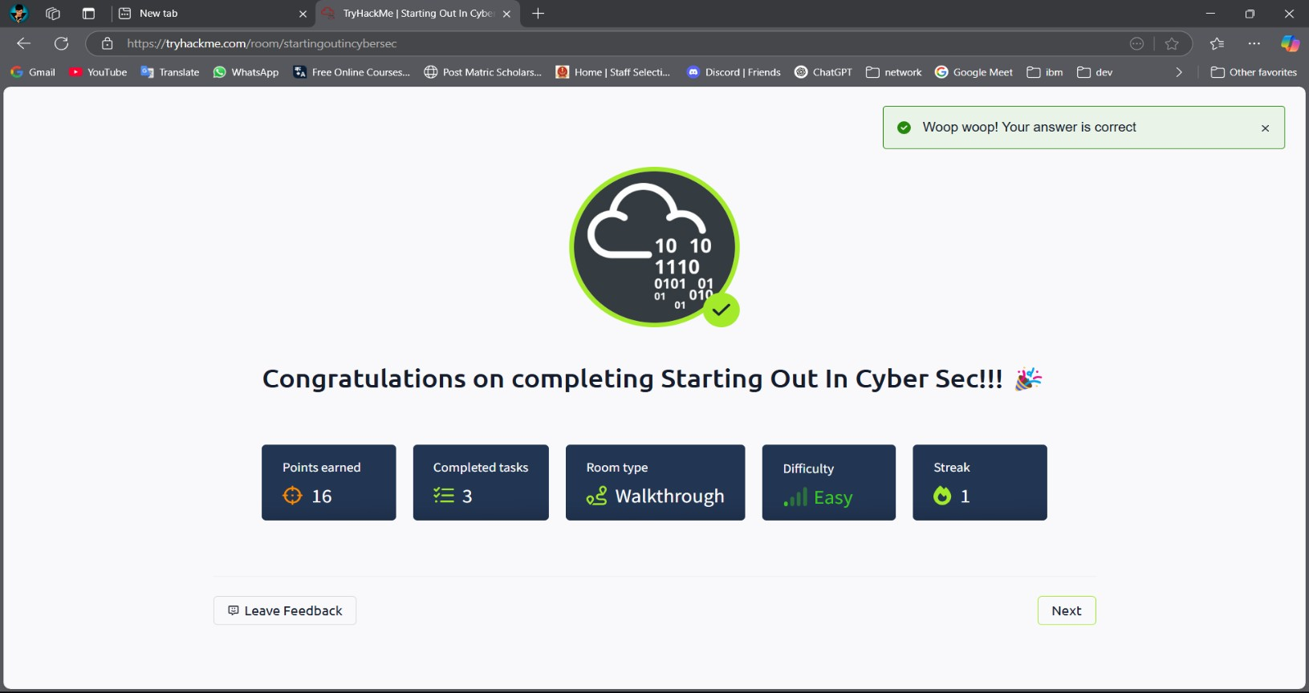

## TryHackMe Room: [Introduction to Research](https://tryhackme.com/room/introtoresearch)

**Learning Objective**

The "Introduction to Research" room on TryHackMe aims to equip users with fundamental research skills essential for cybersecurity.

**Key Tools/Commands Used**

* **Search Engines (Google, DuckDuckGo)**
* **Online Databases (e.g., NIST, CVE)**
* **Documentation and Whitepapers**

**Concepts Learned** 1. **Effective Searching:**

* + Understanding how to formulate effective search queries using relevant keywords and operators.
  + Learning how to refine search results to find accurate and relevant information.

1. **Credible Sources:**
   * Identifying and evaluating the credibility of online sources, including documentation, academic papers, and vendor websites.
   * Understanding the importance of using reputable sources for reliable information.
2. **Utilizing Databases:**
   * Exploring and using online databases such as NIST's National Vulnerability Database (NVD) and the Common Vulnerabilities and Exposures (CVE) database.
3. **Research Methodologies:**
   * Learning basic research methodologies for cybersecurity tasks, such as threat analysis, vulnerability assessment, and incident response.

**Walkthrough / How You Solved It**

1. **Accessing the Room:**
   * Logged into TryHackMe and navigated to the "Introduction to Research" room via the provided link [(TryHackMe Introduction to Research)](https://tryhackme.com/room/introtoresearch).
2. **Understanding Search Techniques:**
   * Learned how to use search engines effectively by formulating relevant queries.
3. **Exploring Databases:**
   * Explored online databases such as NIST NVD and CVE to search for vulnerabilities.
   * Learned how to use these databases to gather information for security-related tasks.
4. **Task Completion:**
   * Answered questions related to research techniques, credible sources, and database utilization.

**Reflections or Notes**

* This room is crucial for developing essential research skills needed for any cybersecurity professional.
* Mastering these skills is fundamental for staying informed about emerging threats, vulnerabilities, and security best practices.

